**The Unit Name:** R function to sum up all temperature values

**Participants:** Temirlan Bayeshov

**Pass/Fail criteria:** testthat library will be used. First our main code will call calTempSum function, to take all temperature values from database and sum them up. After it will call test_Temp function to make unit test for a temperature final value. We will check if value type is data frame or not, because we should make a data frame to take values from database and sum them, and second test will check if there is only single value of temperature sum. In script we used expect_that function from the testthat library.

**Results:** We obtained success in both tests, because our final temperature value is single and data frame. So, as expected we the R unit test for temperature passed without any failures.

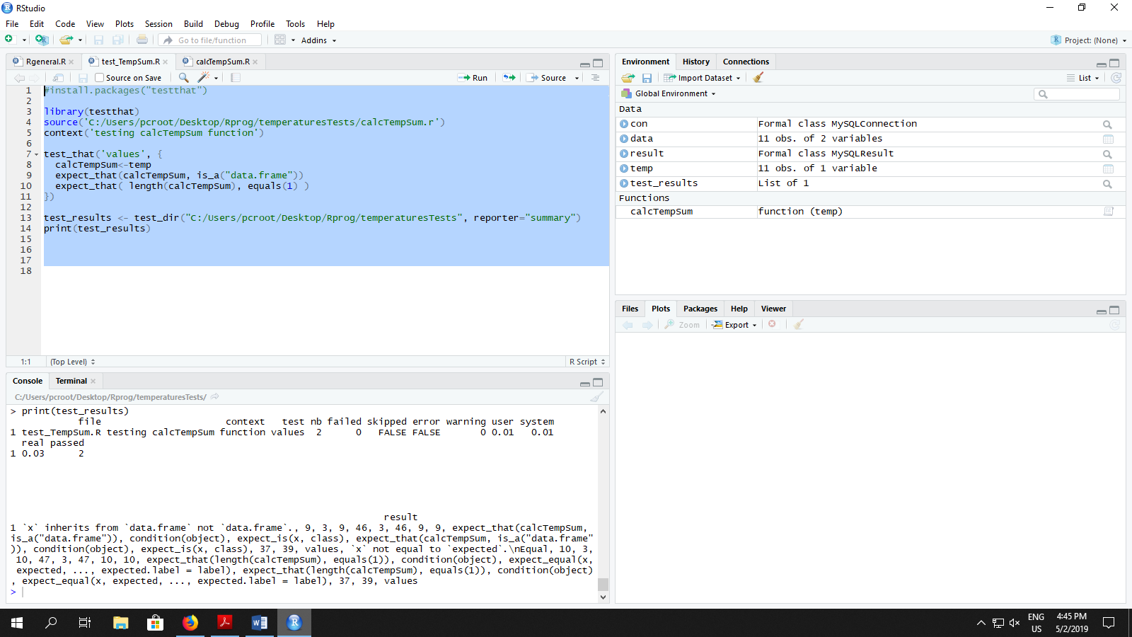

**The Unit Name:** R function to sum up all humidity values

**Participants:** Temirlan Bayeshov

**Pass/Fail criteria:** testthat library will be used. First our main code will call calHumiditySum function, to take all humidity values from database and sum them up. After it will call test_Humidity function to make unit test for a humidity final value. We will check if value type is data frame or not, because we should make a data frame to take values from database and sum them, and second test will check if there is only single value of humidity sum. In script we used expect_that function from the testthat library.

**Results:** We obtained success in both tests, because our final temperature value is single and data frame. So, as expected we the R unit test for humidity passed without any failures.

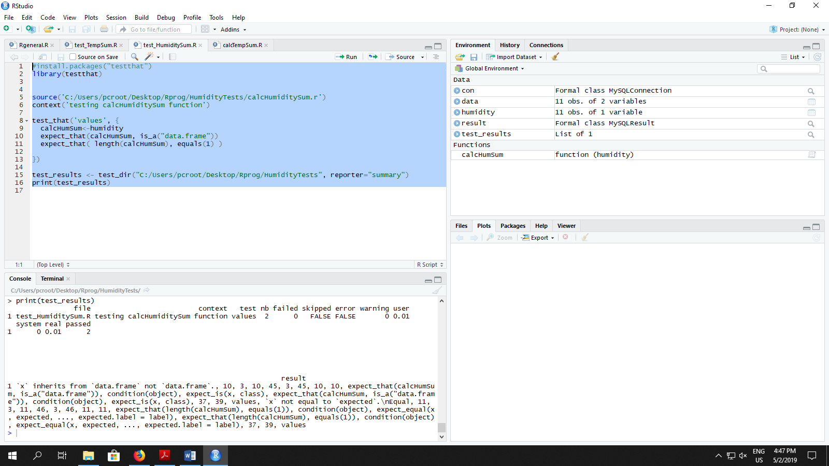

**Summary of the Tests Passed**

1. R function to sum up all temperature values passed. As we expected we made our values from INT type to Data Frame type. After getting all values from database we summed the up and we get only single value at the result. Both unit tests passed successfully.
2. R function to sum up all humidity values passed. As we expected we made our values from INT type to Data Frame type. After getting all values from database we summed the up and we get only single value at the result. Both unit tests passed successfully.